Equality operator

Plus operator

Contains operator

Rule Reader

Rule Validator

Data stream Reader

Rule engine

For each rule, there is a rule validator. For a rule, operator is representing by “IRuleOperator” interface.

Instruction for defining rules.

Operator supports by application – Contains , +, ==

1. Contains:
   1. This operator can be use with string and for other data type this operator is not applicable on rule.
   2. To find a part of string, this operator can be use.
   3. Example : ALT1 contains hig
2. Equality(==):
   1. This operator can be use with string and integer data type and for datetime data type operator is not valid.
   2. With both data type “==” operator will check value and operand are same or not.
   3. Example: ALT1 == 5 or ALT2 == “FirstSample”
3. Plus (+)
   1. This operator can be use with string and integer data type and for datetime data type operator is not valid.
   2. With integer data type “+” operator will add values
   3. With string data type “+” operator will connate strings.
   4. Example: ALT1 + 2 == 5 or ALT2 + “Sample” == “FirstSample”

Note:

1.Operator and operand must have space between.

2. data stream json must be in following format

{

"DataArray":[

{“signal”:”ALT1”,”value”:”Sample”,”value_type”:”string”},

{“signal”:”ALT1”,”value”:”Sample”,”value_type”:”string”}

]

}

1. Rule engine is a singleton class which allow user to read data from json file, read rules from rule text file and start validating rules on relevant data.
2. Interface IRuleValidator validate a rule on data and data automatically get from json.
3. Interface IRuleOperator use to represent operator in rule.

Few screenshot from application

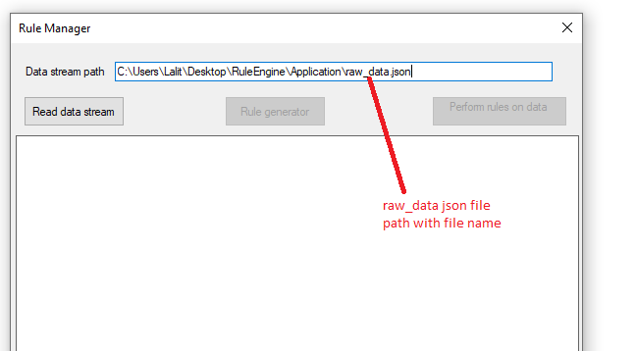

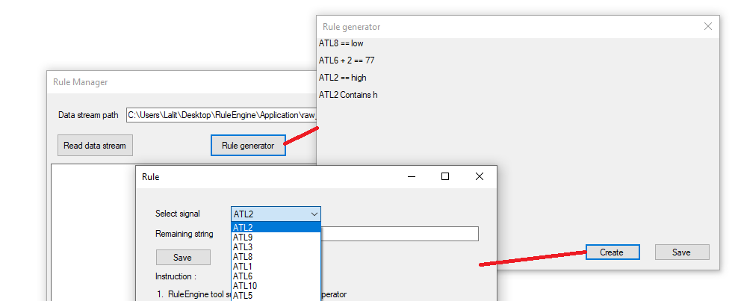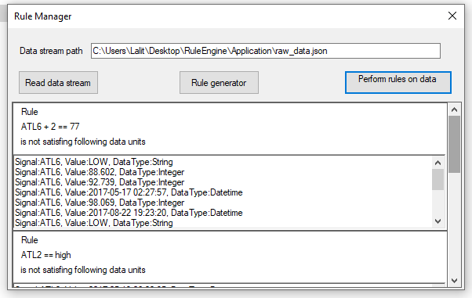

Complexity: O(n) where n is number of relevant data units for a signal

Enhancement:

1. Can have a facility to add multiple level of operators in a rule
2. Can have a number of operators so in creation of rule can be more flexible.
3. Can have different type of validators that will implement IRuleValidator